Business Requirements Document

OWEN Lite

Author: Rashmi Tekchandani / Aditya Doshi

Version: 0.1

Date: 4 May 2017

Table of Contents

1 Executive Summary 3

2 Project Description 3

3 Project Scope 3

3.1 In Scope 3

3.2 Out of Scope 3

4 Business Drivers 4

5 Proposed Process 4

6 Functional Requirements 4

6.1 Priority 4

6.2 Requirements Category - Admin 5

6.3 Requirements Category - HR 5

6.4 Requirements Category - Employee 5

7 Non-Functional Requirements 6

8 Glossary 7

9 Document History 8

# Executive Summary

OWEN Lite is a web-based SaaS to test the use of HR Analytics in the real world. It will provide an insight from employee experience to the overall health of the organization. This will be measured by surveys taken by the employee and the anonymous results viewed in a dashboard format by the HR.

# Project Description

OWEN Lite would be useful as employee experience tool where in employees would be able to take surveys which has combination of ME and WE questions and HR would get insights through network analysis derived out of survey

# Project Scope

This is the MVP. This web-based SaaS is supposed to help assist organizations in evaluating their internal networks, by conducting surveys as well as understand the organization’s sentiment. Users must sign up for this web-based SaaS on www.owenanalytics.com/signup. They will need to make a payment, after which their services begin.

OWEN Lite involves 3 users, Admin, HR and Employee.

The Employee undertakes surveys. The HR monitors the dashboard for network metrics and sentiment metrics, as well as undertake surveys themselves. The Admin can update the employee master, add/remove questions, change frequency of the survey, set select employees as HR, as well as undertake the surveys.

## In Scope

The following areas are in scope for this project:

* Signup process on owenanalytics.com website
* Automatic role allocation, based on employee master upload
* User login
* Survey mechanism
* HR Dashboard
* Admin page
* SSL Certificate

## Out of Scope

The following areas are out of scope for this project:

* Chatbots
* Voice to text (sentiment analysis)
* Payment mechanism
* Multi language
* Native App (iOS/Android/Windows)
* Only one device login limit

# Business Drivers

* Improve sales revenue
* Improve efficiency in an existing system or process
* Upgrade of an older system

# Proposed Process

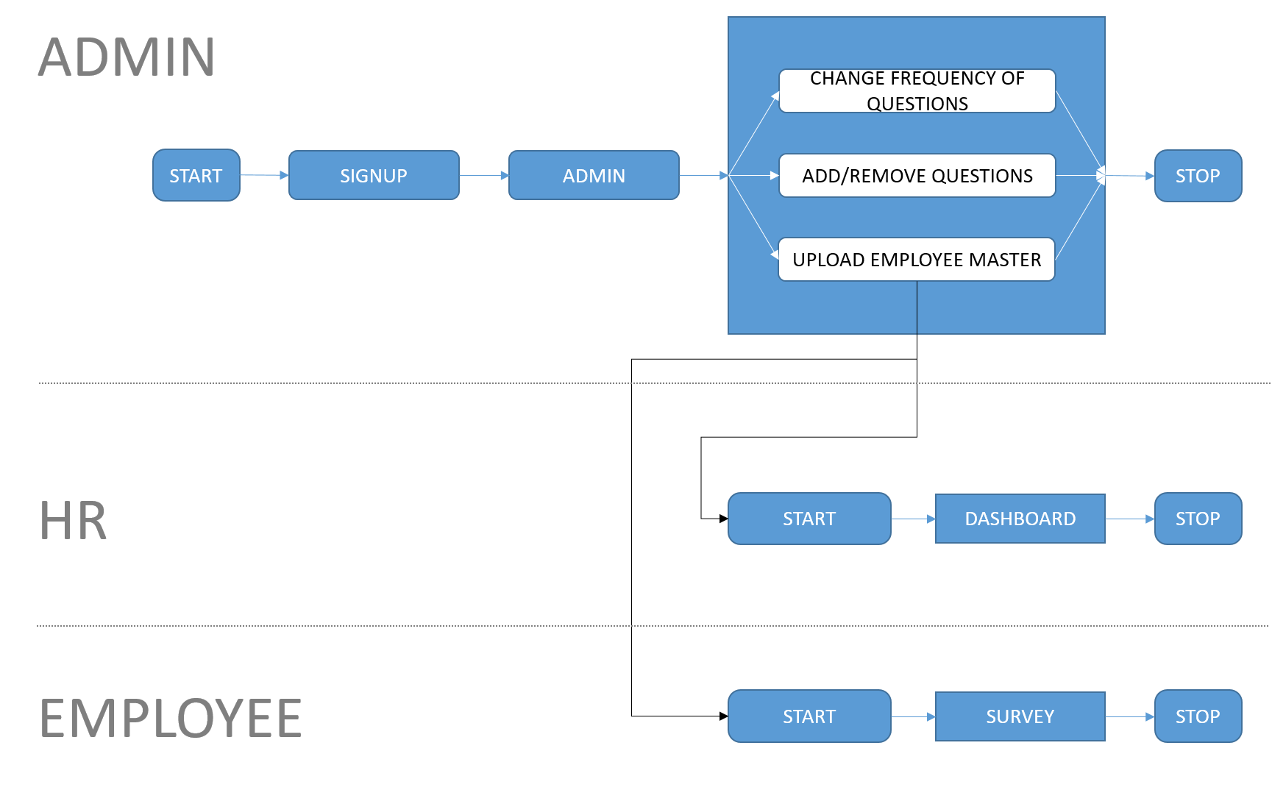

# Functional Requirements

## Priority

The requirements in this document are divided into the following categories:

|  |  |  |
| --- | --- | --- |
| **Value** | **Rating** | **Description** |
| 1 | Critical | This requirement is critical to the success of the project. The project will not be possible without this requirement. |
| 2 | High | This requirement is high priority, but the project can be implemented at a bare minimum without this requirement. |
| 3 | Medium | This requirement is somewhat important, as it provides some value but the project can proceed without it. |
| 4 | Low | This is a low priority requirement, or a “nice to have” feature, if time and cost allow it. |
| 5 | Future | This requirement is out of scope for this project, and has been included here for a possible future release. |

## Requirements Category - Admin

|  |  |  |
| --- | --- | --- |
| **ID** | **Requirement** | **Priority** |
| ADM 1 | Sign Up | Critical |
| ADM 2 | Payment | Future |
| ADM 3 | Upload Employee Master | Critical |
| ADM 4 | Add/Remove Questions | Medium |
| ADM 5 | Change Frequency of Questions | Medium |
| ADM 6 | Access HR Dashboard | Critical |
| ADM 7 | Access Employee Survey | Critical |

## Requirements Category - HR

|  |  |  |
| --- | --- | --- |
| **ID** | **Requirement** | **Priority** |
| HR 1 | Login | Critical |
| HR 2 | Dashboard (Word Association/Cloud, Network Diagram, ME/WE score charts) | Critical |
| HR 3 | Survey | Critical |

## Requirements Category - Employee

|  |  |  |
| --- | --- | --- |
| **ID** | **Requirement** | **Priority** |
| EMP | Login | Critical |
| EMP 2 | Survey | Critical |
| EMP 3 | Change Password | Future |
| EMP 4 | Only one device login limit per user | Future |

# Non-Functional Requirements

|  |  |
| --- | --- |
| **ID** | **Requirement** |
| NFR | Page Load time for Admin should be under 5 seconds |
| NFR | Page Load time for HR should be under 5 seconds |
| NFR | Page Load time for Employee Survey should be under 5 seconds |
| NFR | Survey Submit time should be under 5 seconds |
| NFR | Max Concurrent User 300 |

# Glossary

|  |  |
| --- | --- |
| **Term** | **Explanation** |
| SaaS | Software as a Service |
|  |  |
|  |  |
|  |  |
|  |  |
|  |  |
|  |  |
|  |  |
|  |  |

# Document History

|  |  |  |  |
| --- | --- | --- | --- |
| **Version** | **Date** | **Changes** | **Author** |
| 0.1 | 04/05/20017 | First Draft | Rashmi/Aditya |
| 0.2 |  |  |  |
| 0.3 |  |  |  |
| 0.4 |  |  |  |
| 0.5 |  |  |  |